Accessing Omnissa Horizon Desktops
Open your web browser and navigate to: https://customerconnect.omnissa.com/downloads/info/slug/virtual_desktop_and_apps/omnissa_horizon_clients/8
- Click on “Go To Downloads.”
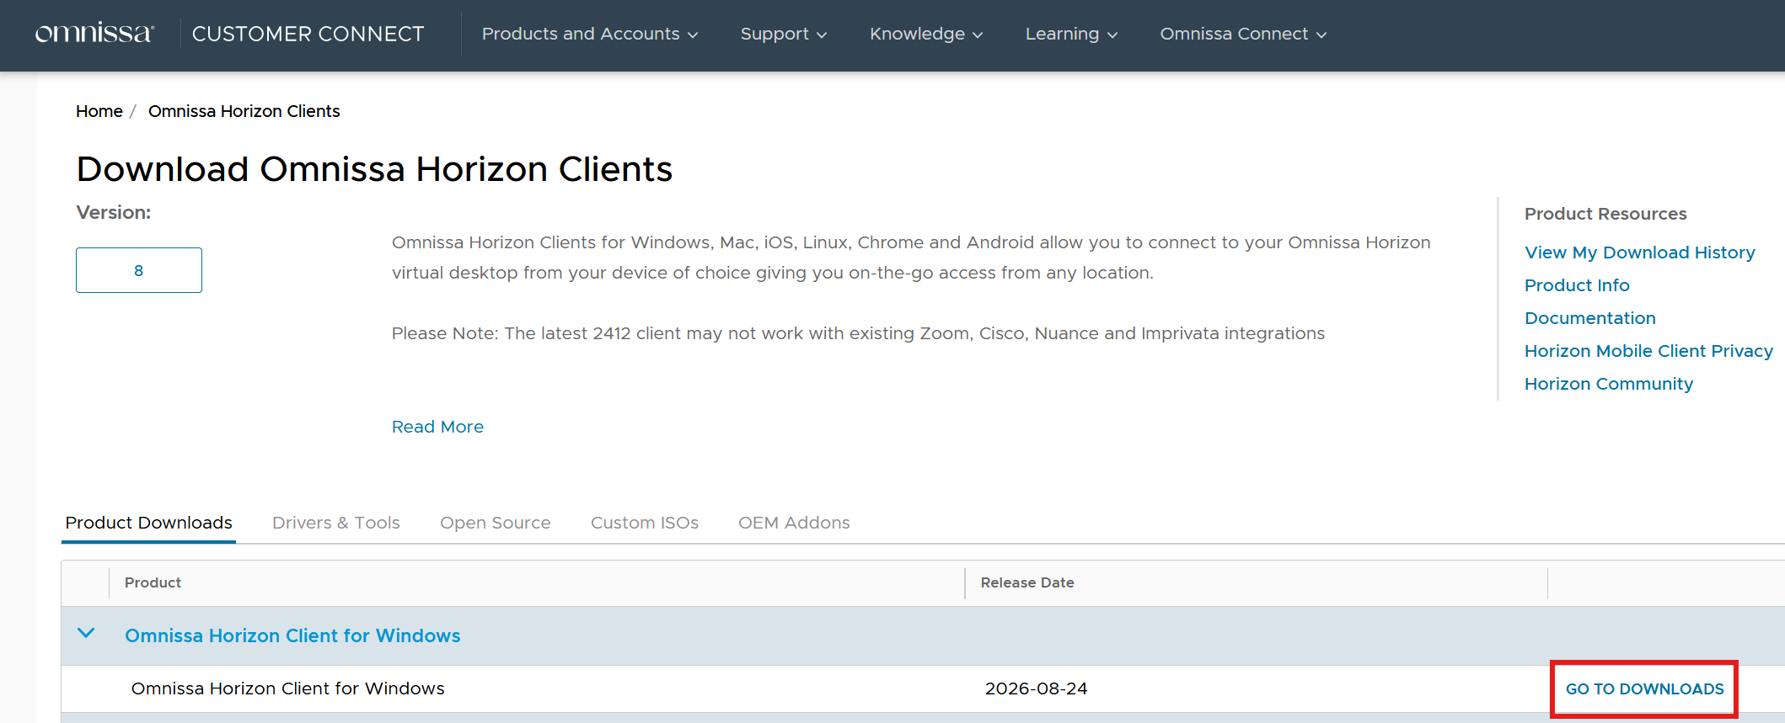

- Select the Download Now button to download the Omnissa Horizon Client for Windows.
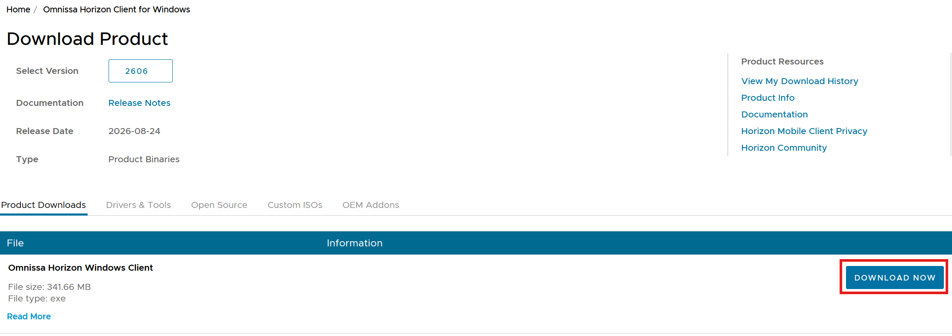

- Once the download is complete, launch the application. By default, it should have been saved to your Downloads directory.
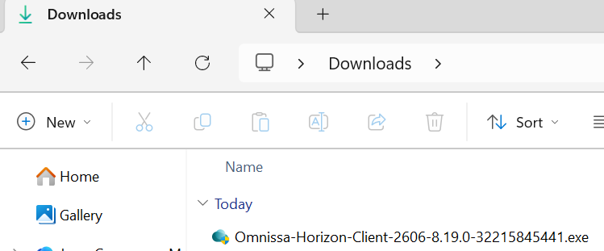

NOTE: If you do not have administrative rights on your machine, you will need to contact your local IT for assistance installing.

- Select Customize Installation.
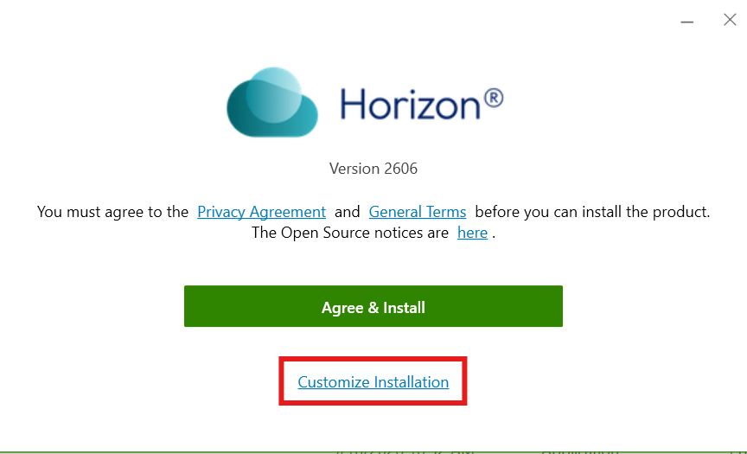

Verify that all settings are configured as shown below, then select Agree & Install. You do not need to modify the “Where to install” field.
  - *IMPORTANT* The software may force a restart of the workstation under certain scenarios. Save your work and shut down any open applications first.
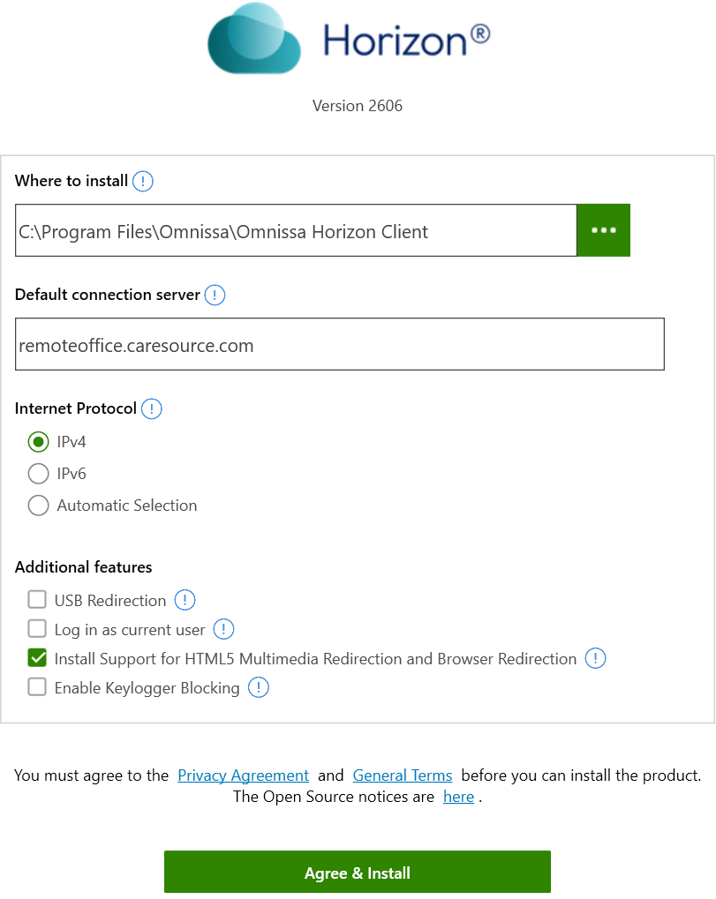

- The application will install multiple components. You should see prompts like the one below during the installation process.
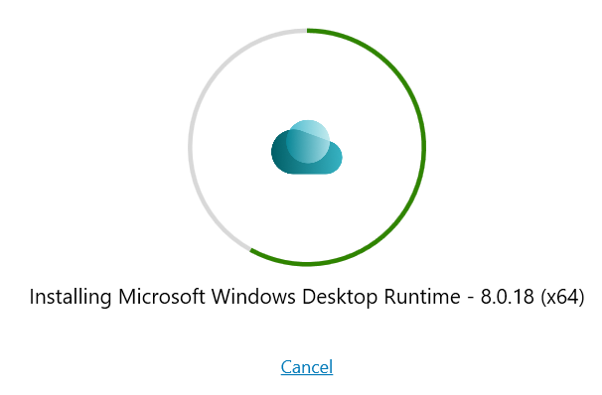

- When the installation is complete you will receive the pop up below.
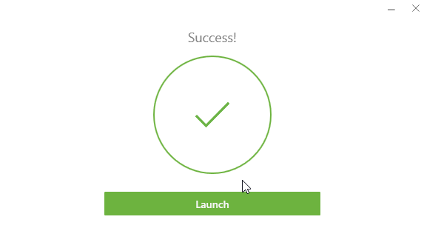

- If you are prompted to reboot your machine, be sure to save any important information, close any open applications, then select Restart Now to reboot your machine.
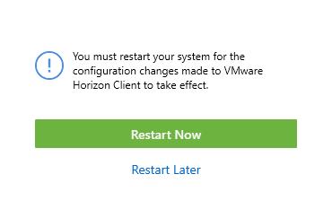

- Once the computer restarts and you have logged back in, double-click the new icon on your desktop labeled Omnissa Horizon Client.
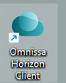

- When the application launches, double click the URL you configured in the setup process earlier. If you forgot to add the URL you can select New Server too add it now.
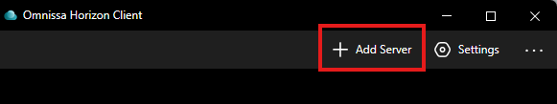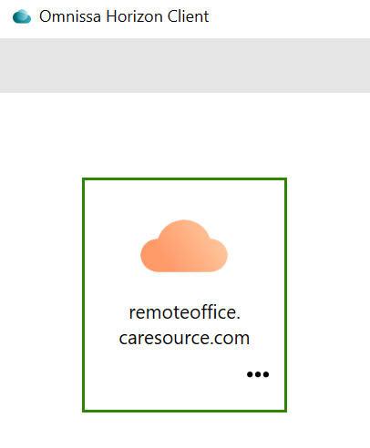

Accept the disclaimer.
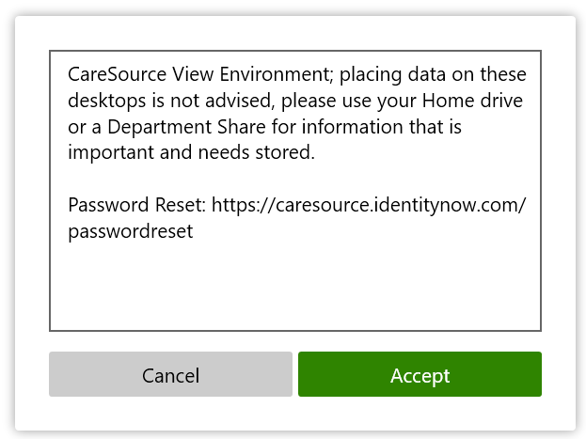

Enter your CARESOURCE username and password then select Login.
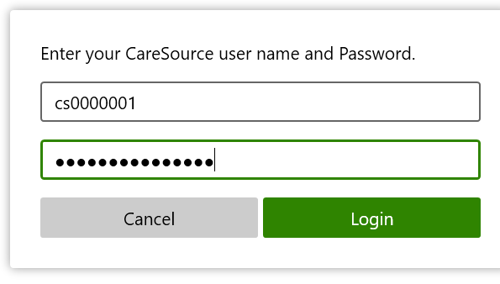
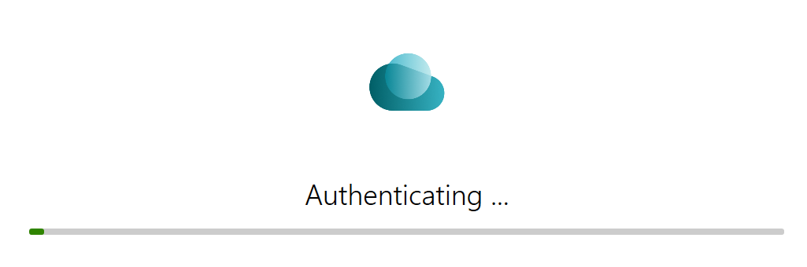

Depending on which factors you enable within Okta, your experience will differ. Review each scenario below. If you need information on enrolling in Okta, please contact the service desk.
  - Okta Verify- If you are enrolled with Okta Verify, a push approval notification will automatically be sent to your Okta Verify enrolled mobile device. To complete the authentication, just approve the access from your device by tapping “Yes, it’s me” and you will be presented with your list of available desktops for VDI.
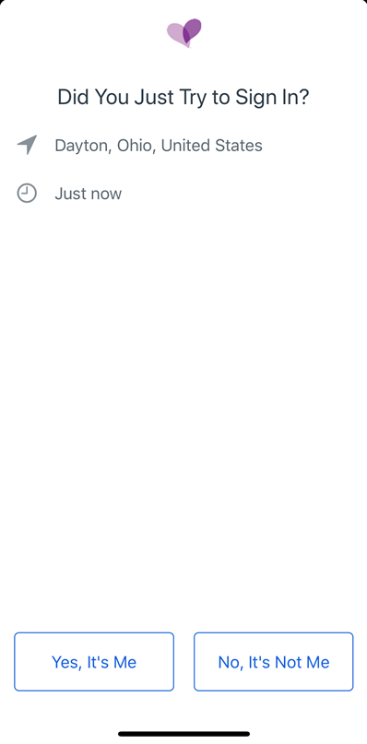

If your Okta Verify enrolled mobile device is locked, you will see a notification like the one below. Just unlock your mobile device and approve the sign on as shown above.
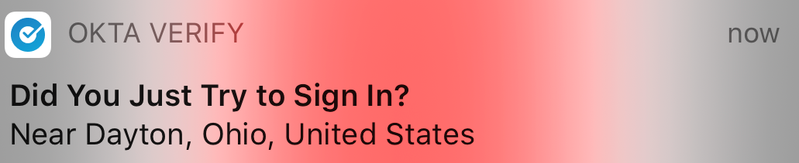

If you have a smart watch associated with your Okta Verify enrolled mobile device, your push notification can be delivered and approved through your smart watch. Sample notification shown below-
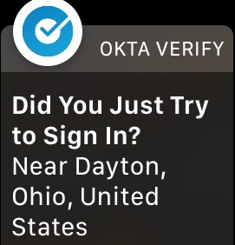

Once you approve the sign-in attempt from your Okta Verify enrolled mobile device, you will be presented with your list of available desktops for VDI.

  - SMS/Text or Voice Call- If you are not enrolled in Okta Verify and have chosen to enroll in SMS/Text or Voice Call pin delivery, you will be presented with the following screen-
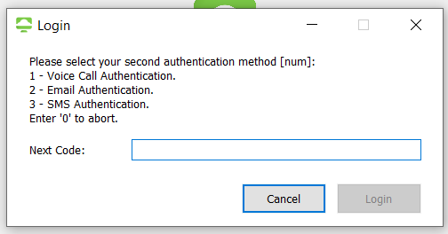

Type the number associated with the factor you wish to use to have your PIN code delivered into the Next Code field. For instance, in the example above, you would type the number <3> if you wanted your PIN code delivered via SMS/Text message to your enrolled phone number. Click Login to initiate the SMS/Text or Voice Call PIN delivery.
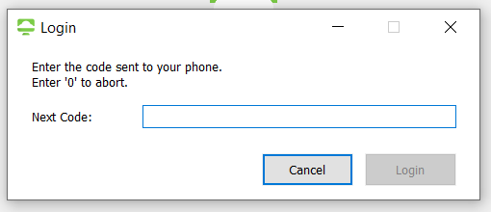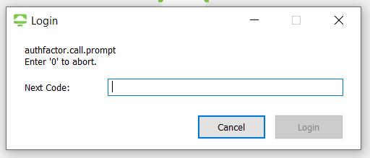

Enter the code you received either by SMS/Text delivery or by phone call in the Next Code field. Click Login. You will now be presented with your virtual desktops.
  - Email PIN delivery- For users external to CareSource with a non-CareSource email address, you may choose to retrieve your 6 digit PIN code via your email. In the Next Code field, type the number associated with the “Email” factor and click Login to have your PIN code delivered to your email.

For instance, in the example above, you would type the number <2> if you wanted your PIN code delivered via Email to your email address. Click Login to initiate the Email PIN delivery.
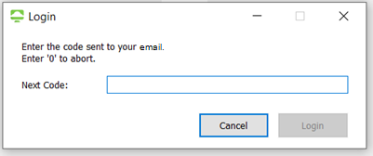

Enter the code you received either by email in the Next Code field. Click Login. You will now be presented with your virtual desktops.
If you are internal to CareSource and/or have a CareSource email address, you should not use email to retrieve your PIN unless you have access to your CareSource email address outside of VDI.

  - If you have not enrolled in any factor within Okta and you try to sign-in, an email PIN will be sent to your corporate email account. This is unique to the Horizon client login experience and does not work with HTML/browser access. If you have access to your corporate email, you may enter the PIN you received in the Next Code field and click Login.
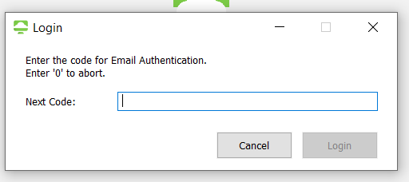

If you receive the error message below, you need to modify Settings. This is typically due to a configuration on your local machine (VPN, Proxy, Zscaler, etc). If you do not receive this error, skip to Step 19.
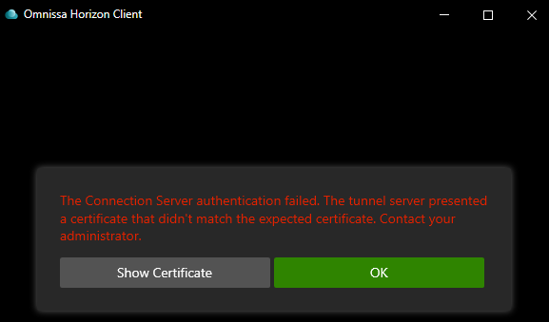

Select OK and navigate to Settings.
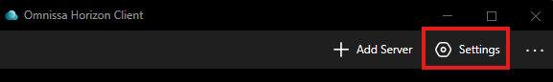

Select Security and set “Certificate checking mode” to “Do not verify server identity certificates.” Select the back arrow and attempt to connect again.
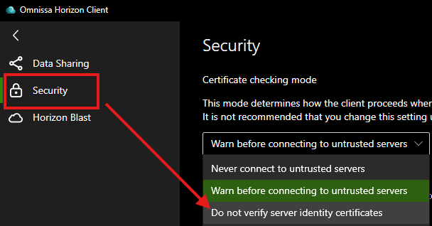

You will be presented with a list of the desktops you have been entitled to access. Double-click the one you need.
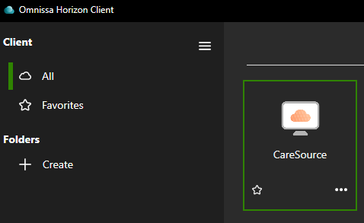

The connection to the desktop will begin.
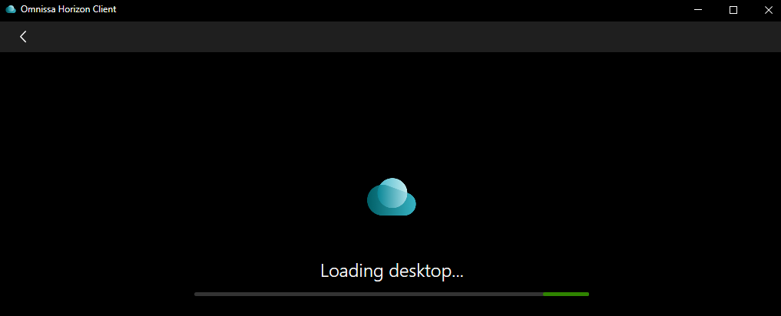

Once connected, you will have access to the desktop, which acts and performs just like a normal workstation.
When finished with the desktop, be sure to log out following one of the processes outlined below.

How to Properly Log Out of a VDI Desktop

Using Windows 11 Start Menu
- When you are finished working, please close all open applications and log out using one of the two following methods: Select the Start Menu > Select your name > Select ‘…’ > Sign Out or Right click on the Start Menu > Select “Shut down or sign out” > Sign out.
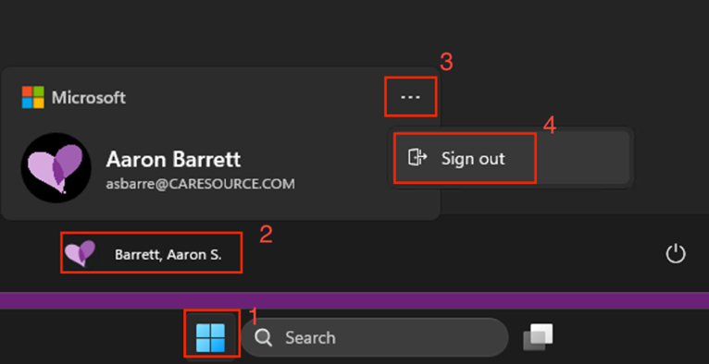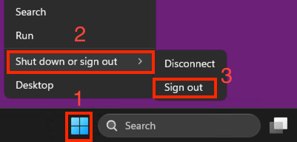

- You might see this box after you log out, please leave it up and it will close out on its own. Do not close the session’s window, it will close out and return you to the home screen on its own.
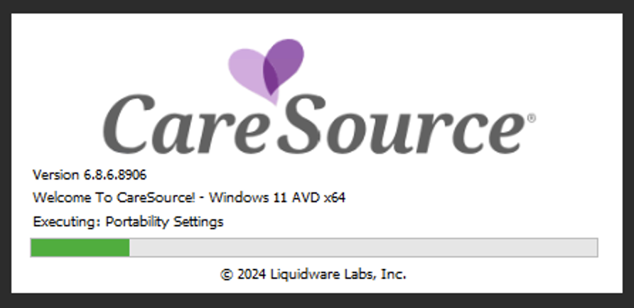

Using the Omnissa Horizon Client
- Left click on Options from the toolbar at the top
- Left click on Disconnect and Log Off
